**GOVERNMENT ARTS COLLEGE, UDHAGAMANDALAM**

**DEPARTMENT OF PHYSICS**

**Mentor:** Dr S.Venkateshwari

**Team leader:** Viji R

**Team member 1:** Yoganandhan R

**Team member 2:** Premkumar S

**Team member 3:** Ashwin D

**Team member 4:** Mothis Rao B

**PROPERTY MANAGEMENT APPLICATION USING SALES FORCE**

**1.INTRODUCTION**

**1.1: OVERVIEW**

This project aims to develop for the Property Management where Buyer can order his Requirements and get the Appropriate Details of the Property. According to his interest just provide him with some discount up to what extent he can get the discount. Also Track Whether he is Interested in taking the loan available for so just calculate how much loan Amount user can get it. Provide the Security for two different profiles like for marketing and sales team. Then Finally Create the report and dashboard so there will be clear view just get the reports on the count of loan passed getting the property purchased close the deal.

**1.2. PUROSE**

Property Management: A few real estate brokers also work as property mangers in land management. They may provide services to buyer`s agents, as well as property management services.

Property Management is the supervision for residential, Commercial & Industrial Including Apartment. It involves adminsitring property owned by another part. And keeping all the Information Regarding Properties and help customers to get property as per there requirements.

For various reasons, property owners are hiring property management firms. Some landlords may have many rental properties in their portfolio but lack the expertise or time required to maintain the properties and deal with the tenants. Some owners have only an interest in owning rental property and profiting from them. They have professional real estate managers in this situation.

**2 PROBLEM DEFINITION & DESIGN THINKING**

**2.1: EMPATHY MAP**

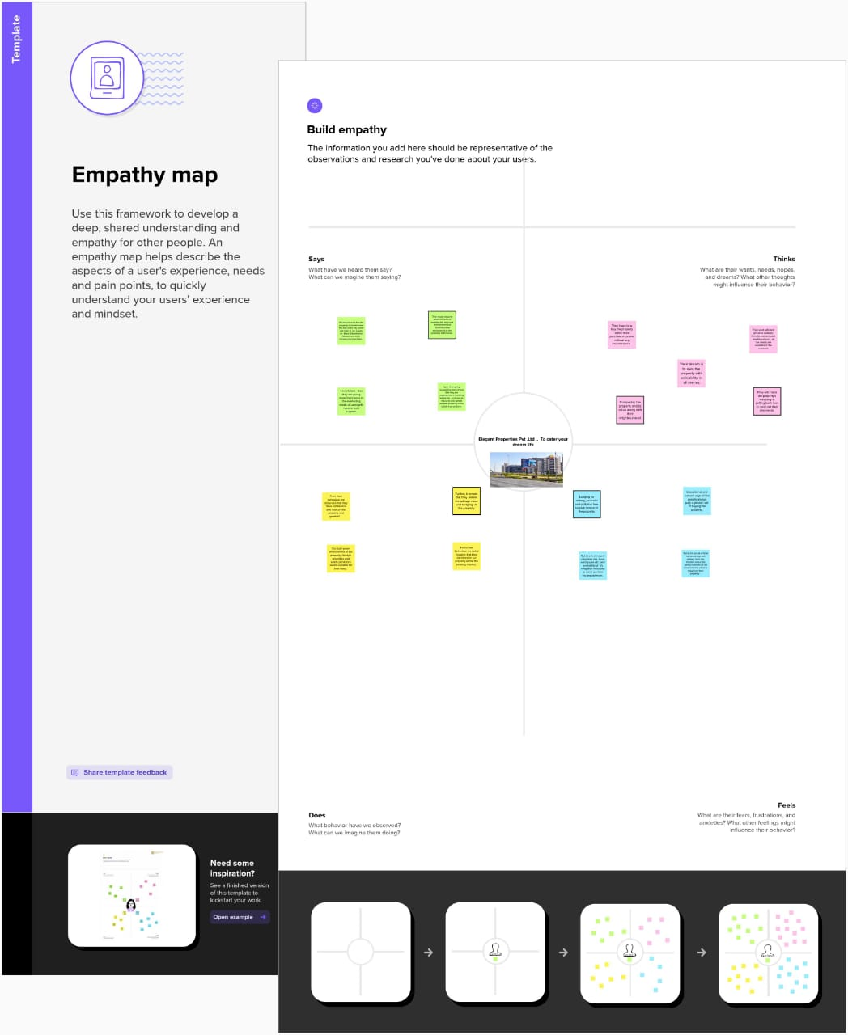

**2.2 IDEATION & BRAINSTORMING MAP**

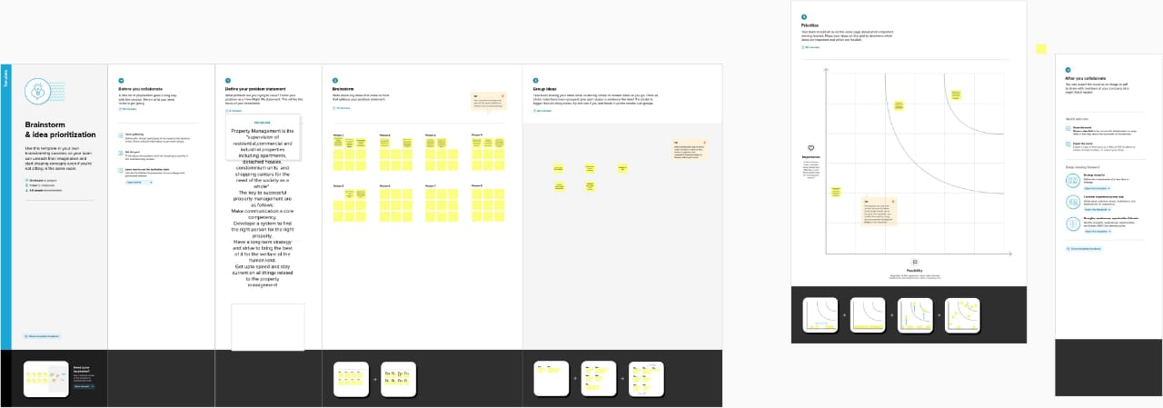

**3 RESULT**

**3.1 DATA MODEL**

|  |  |  |  |  |  |  |  |  |  |  |
| --- | --- | --- | --- | --- | --- | --- | --- | --- | --- | --- |
|  | **OBJECT** | | FIELDS IN THE OBJECT | | | | | | |  |
| **BUY** | |  | | **FIELD LABLE** | | | **DATA TYPE** | |  |
| JOB TITLE | | | TYPE | |
| Amount label | | | Number | |
| BUY | | | Text | |
| BUY NAME | | | Text | |
| CITY | | | Text | |
| CREATED BY | | | Look up | |
| DISCOUNT | | | percent | |
| LAST MODIFIED BY | | | Look up | |
| OWNER | | | Look up | |
| PROPERTY TYPE | | | Pick list | |
| RENT | | | Text | |
| STATE | | | Pick list | |
| **LOAN** | |  | | ANNUAL LOAN | | | NUMBER | |
|  | | CREATED BY | | | LOOK UP | |
| INTREST RATE | | | CURRENCY | |
| LOST MODIFIED BY | | | LOOK UP | |
| LOAN | | | LOOK UP | |
| LOAN AMOUNT | | | NUMBER | |
| LOAN ID | | | AUTO NUMBER | |
| LOAN NAME | | | TEXT | |
| LOAN REPAYMENT | | | NUMBER | |
| OWNER | | | LOOK UP | |
| TEAM | | | NUMBER | |
| TOTAL LOAN INSTALMENT | | | NUMBER | |
| **RENT** | |  | |  | | |
| CREATED BY | LOOK UP | |
| LAST MODIFIED BY | LOOK UP | |
| OWNER | LOOK UP | |
| RENT | AUTO NUMBER | |
| RENT NAME | TEXT | |
| RENTAL | TEXT | |

**3.2 ACTIVITY & SCREENSHOTS:**

**Milestone 1:** Creation of Developer Account

**Description:**

We had created a developer account and verified it for the salesforce project.

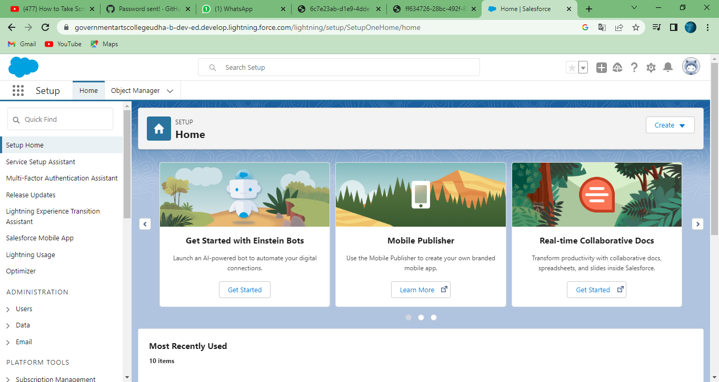

**Milestone 2: Object**

**Description :**

Created a custom object with a label named “Buy”, “Loan” and “Rent”.

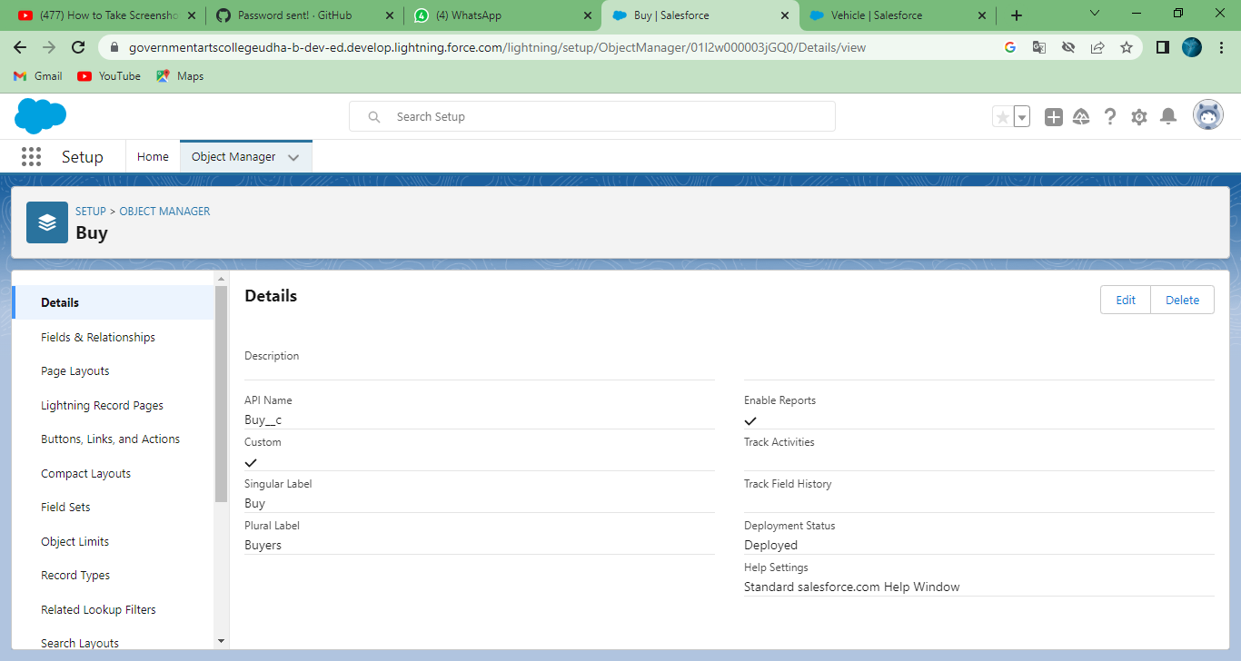

**Milestone 3 :** Fields

**Description :**

Created a fields and relationship for by object Buy, Rent, Loan Detail Relationship

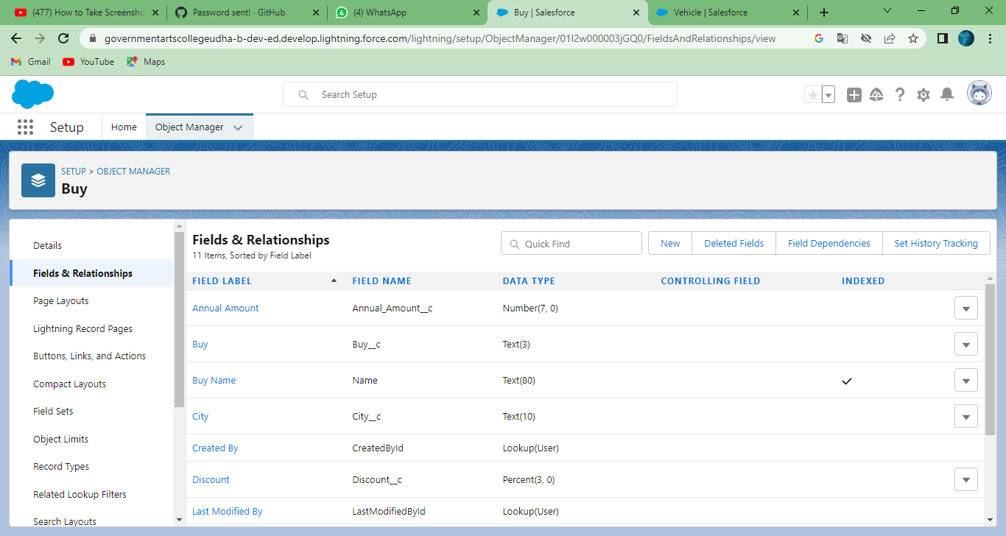

**Milestone 4 :**

**DESCRIPTION :**

Created a tab for “ Buy”, ”Rent” and “Loan”

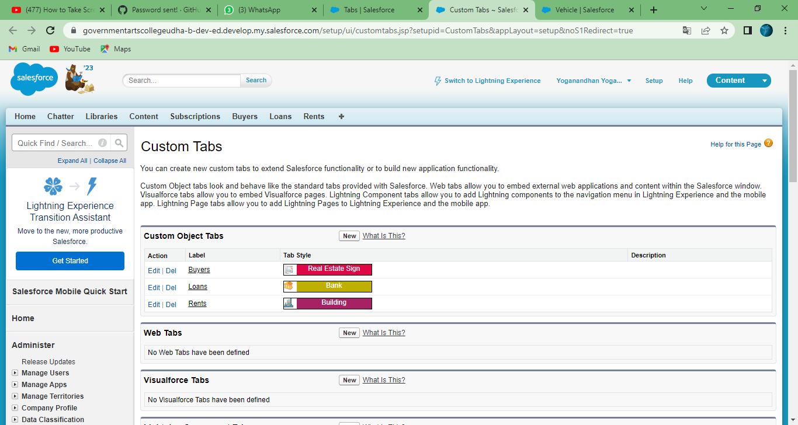

**Milestone 5 :** Profile

**Description :**

Created a custom profile for “ Buy”,”Loan” and “Rent”

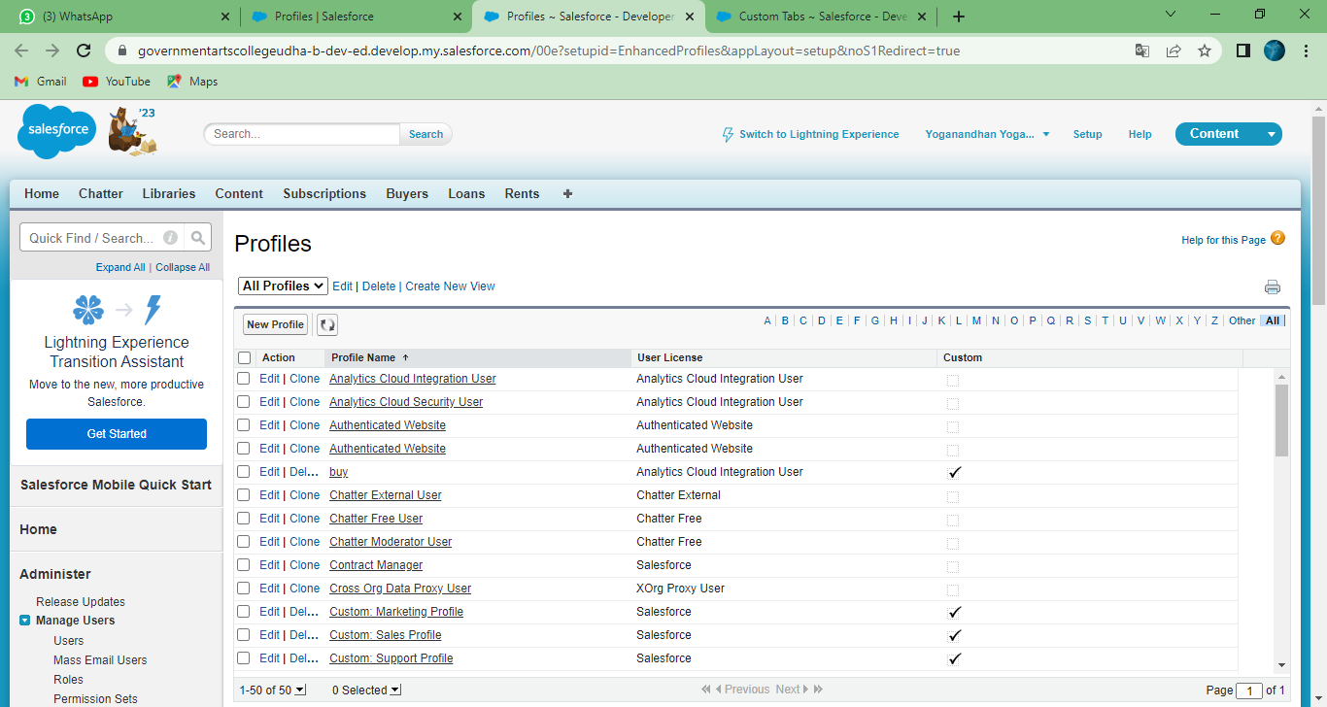

**Milestone 6:** Users

**Description :**

Created a user for a Marketing Manager as “Kumar Sam”

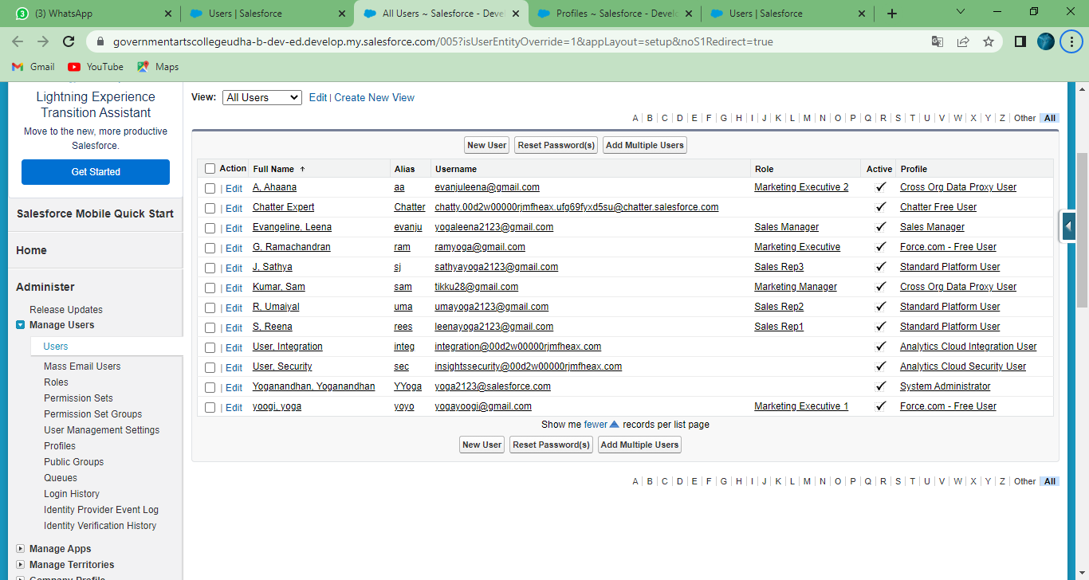

**Milestone 7**: Permission Setting

**Description :**

Created a Permission set for Buy, Rent, Loan

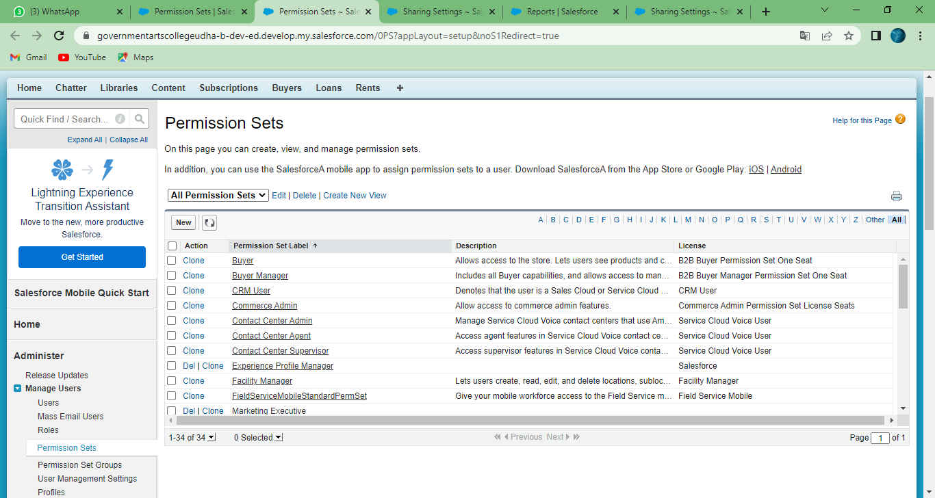

**Milestone 8** : Reports

**Description:**

Created a report using object Buy, Loan and Rent Property Management.

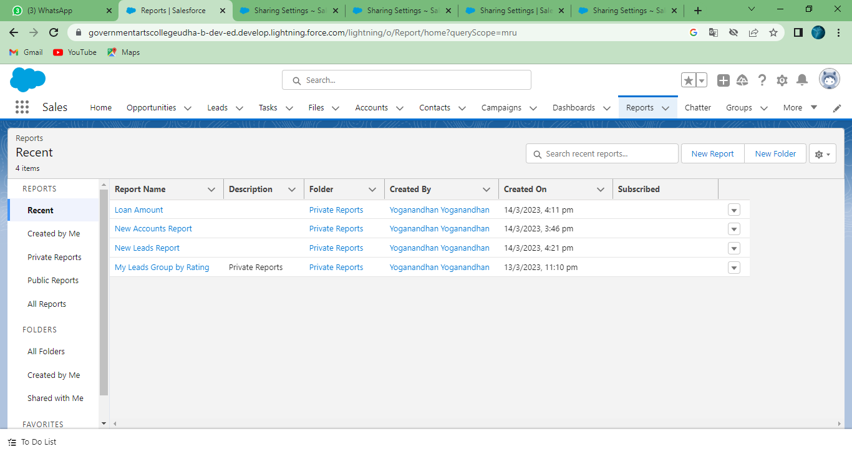

4. TRAILHEAD PROFILE PUBLIC URL:

**Team Leader (Viji ) :** https://trailblazer.me/id/vijir11

**Team Member 1(Yoganandhan**): https://trailblazer.me/id/yoganandhan

**Team Member 2(Prem kumar):** https://trailblazer.me/id/pkumar4692

**Team Member 3(Ashwin):** **https**://trailblazer.me/id/ashwd6

**Team Member 4(Mothis Rao):** https://trailblazer.me/id/mothisrao

**5.1 ADVANTAGES OF THE PROPERTY MANAGEMENT APPLICATION SYSTEM USING SALESFORCE PROJECT:**

* Reduces add-ons
* Saves time
* Minimizes the administration costs
* Represents a centralized, efficient document platform
* Facilitates managing orders
* Allows creating [user-tailored property management forms](https://www.cmwlab.com/forms-workflow/)
* Saves money
* Provides insight into daily managerial tasks
* Provides real-time coordination between multiple users
* Facilitates delegating work and keeping up with the deadlines
* [Notification](https://www.cmwlab.com/blog/workflow-notifications/) and alert feature
* Improves communication between the employees and colleagues by introducing task discussions
* Facilitates the owner-tenant communication
* Decreases chances of misunderstanding and disputes
* Organizes your trust account audit data
* Automatizes daily operational workflow
* Automatizes finances and maintenance.

In addition, as this is a cloud-based software, it is also:

* Cheaper than the server-based software
* It provides automatic backups
* It has increased flexibility and efficiency
* Impeccable accessibility
* Scalability
* Remote-access option
* Integration with other software and channel managers
* Accessible from different devices.

**5.2 DISADVANTAGE OF THE PROPERTY MANAGEMENT APPLICATION SYSTEM USING SALESFORCE:**

Disadvantages of property management software installation result from the inadequate use or picking the wrong system for your business. Those include:

* Time-consuming if you choose the wrong system. Make sure you analyze your own business, the scope of the projects you lead and work on and decide on the type of the property management system which will suit you the best. If you are running a small business, choosing a simple, user-friendly interface PMS is the best option.
* Might seem expensive for a small business. However, the system will pay off within less than a year as it will literally start making money for you. The investment is worth the expense in the long run.
* Training (cost and time). This depends on the readiness of your staff to learn. However, the software is user-friendly and everyone should be able to learn how to use it within a week.

In conclusion, there are more pros than the cons. The disadvantages such as price and training should be observed as investments that will pay off within a short period of time. The advantages of the correct choice and use of property management software lead to more free time for other tasks, efficient task delegating, improved communication and organized documentation. [Automated workflows](https://www.cmwlab.com/workflow-automation/) and trust account transaction control are its strongest assets.

**APPLICATIONS :**

* Bookings
* Check-in and check-out
* Telephone systems integration
* Point of sale (POS) integration
* Event planning
* Food and beverage costing
* Hotel inventory supply management
* Reporting of key performance indicators (KPI)
* Security and room locks

**CONCLUSION :**

In conclusion, Property Management System (PMS) software is very crucial for all the Hotels. Especially Opera PMS constitutes the most appropriate PMS software for Hilton Athens. It is user friendly, connects with Central Reservation System (CRS), Point of Sale (POS) etc. and provides all the tools the hotel needs in order to operate effectively.

**Property management has long been overlooked in the real estate industry.**

**FUTURE SCOPE:**

Property managers' work became very appreciated when the world started to suffer a pandemic. Property managers were underrated until their services were imperative to keep rental properties above water.

The twenty-twenties have assured a new era of property management, and here's what we see now and predict more of in the future of property management.

**Resident Oerident**

The pandemic brought on many challenges for not only property managers but their residents as well.  Property managers quickly shifted their attention to assist residents in creating payment plans and even helping people file for financial aid.

Taking care of their resident's needs and keeping them safe became imperative when the pandemic was at its peak. This need created a new trend of more empathetic and flexible property managers. This newfound attitude did not harm the profits but helped keep properties occupied and owners happy.

**Better Communication**

Property managers are communicating more proactively with clients than ever before. Clients want prompt communication, and property managers are using new creative ways and software to streamline it. When there is better communication between managers and clients, it opens up a whole world of opportunities for new services and benefits.

Instant messaging has taken over, leaving emails only for the most formal communications. Clients are contacted for quick decisions expediting matters. The need for better communication was long overdue, and the COVID pandemic pushed it into high gear. Property managers have contacted clients about rent, payment plans, concessions, regulations, maintenance emergencies, and more. Clients have expressed their desire to continue this channel of instant communication indefinitely.

**MORE SERVICES**

Seeing how valuable property management is has made clients seek additional services from their property managers. Owners realized how tough collecting rent and leasing rental properties became during the pandemic, not to mention the ongoing changes to tenant-landlord legislation at a state and local level to remain in compliance with for their occupied properties.

Now they want to take advantage of these services and more. This situation has opened up a chance for property managers to expand their services. Some are already taking advantage of that by adding new services to their roster. They have specialized in evictions, cleaning, outdoor management, and more than your average rent collection and leasing units.

The growth in services means we might see more specialized property management firms. Firms specifically for single-family residential units or commercial multi-family units will become commonplace. That means owners will experience a more catered experience and more attention to their needs.

**THE IMPORTANVE OF TECHONOLOGY**

With the pandemic making life as we know it completely different, we had to find new ways to adapt to social distancing. The property management firms ahead of the curve regarding technology had the advantage.

Do you want to see the unit? Here is a virtual tour. The security guard isn't able to come in today? Don't worry since we have smart locks. So what if we have a hundred new clients to communicate with? Piece of cake with our CRM.

The trend of using software is projected to grow at an unprecedented rate in the future of property management. The growth is expected since the pandemic has catalyzed tech startups that specialize in property management solutions.

Property management firms have no choice but to grow and advance their use of technology to fulfill clients' demands and follow local regulations. Owners wish to see financial data on demand without going through the property manager all the time. They can do that with an owner portal.

Technology became essential when property management team members were suddenly forced to work from home. The integration of technology into the day-to-day operations allowed property managers to operate their business throughout the pandemic. It also allows for the flexibility for remote working even after the pandemic dies down. This step is made possible with technological features like online payments, online property listings, electronic rent applications, online tenant interviews, resident portals, online leasing, and virtual property tours.

Not only are these advances making the job easier for property managers, but prospective and current tenants also enjoying the benefits of the technology. Everything from virtual tours to submitting a rental application and paying rent can now be done with the click of a button. New tenants love the option of virtual tours and leasing.

**CREATIVE WAY TO EARN MORE**

Property managers are looking at more creative ways to increase their incomes. Some property managers are hesitant to become responsible for more properties under the current economic circumstances. At the same time, owners are reluctant to buy more properties.

With this sort of standstill, property managers have opted to figure out more ways to make money creatively such as acquiring portfolios from retiring managers.

**Thank You**